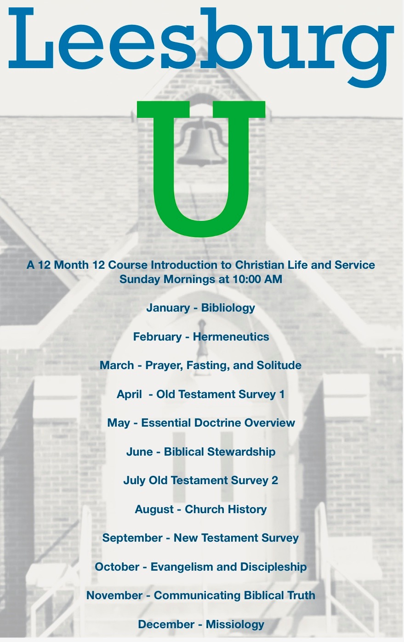

New Adult Sunday School Class to begin January 3rd. Each month will be concentrated on the subject listed. You are welcome to attend only the classes that you are interested in or attend all.

Pastor Jeff will be leading these classes.



Leesburg ECO Presbyterian Church

1831 Perry Highway

Volant, PA 16156

 Jim Schepp

 1st NO DELIVERIES

8th Pat & Prugh Barger

15th George & Betsy Horchler

22nd Frank Baker

29th Pat & Prugh Barger

We would like to thank everyone who participated in our virtual 50th wedding anniversary party through the videos and sentiments sent. We are so thankful for our friends and family who helped make our day extra special. We thank you all for the cards and calls too! ~ George & Betsy Horchler



1 Vallarry Frymoyer 22 Tom Steffan

4 Payton Baughman 23 Kathy Schepp

5 Helen Eshelman Rick Dillaman

11 Tammi Martin Noel Frymoyer

12 Tony Saccol 24 Carol Harris

13 Dave Love 25 Katie Woods

18 Mary Turner 27 Geri Parrott

Doris Steffan 28 Kathy Riley

19 Pete Grimm Amanda Schepp

20 Jeff Hurst 29 Jake Lowry

21 Brad Wilson Max Couch

Brady Wilson 31 Tracy Jaszemski

**SUNDAY SCHOOL CLASSES AVAILABLE:**

**KIDS:**

Ages 3 and under: is lead by Kathy Schepp in the first classroom on the left in the downstairs hallway

Ages 4-6(pre-k and Kindergarten & 1st): is lead by Betsy Horchler in the second classroom on the left in the downstairs hallway

Grades 2 & 3: is lead by Sue Mathieson in the first classroom on the right in the downstairs hallway

Grades 4-5: is lead by Renae & John Shawgo in the youth room at the end of the downstairs hallway.

Grades 6-7-8 (Junior High): is lead by Tammi Martin & Katie Stewart and meets in the last classroom on the left in the upstairs hallway

Grades 9-12 (High School): is lead by Jake Lowry and meets in the “green” room at the rear of the overflow area.

**Adults:**

**Jon Stewart leads the “Homebuilders” in the fellowship hall

**beginning in January Pastor Jeff will host the LEESBURG U class

New Class information below:

We are so excited to announce our plans to begin "Leesburg U" during the Sunday School hour beginning in January. While our other Adult Sunday School Class will still be meeting, these 12 classes will be available for high school students, college students, young adults, and older adults. You can pick and choose topics that interest you or take the whole 12 course curriculum.  They are for anyone who wants to grow more deeply in their faith while being equipped for Christian life and ministry. There will be optional recommended reading to go along with these studies from the best and brightest Christian leaders, pastors, and theologians.  These classes will have a “collegiate" feel to them and will incorporate various teaching models.

The First Session beginning in January will answer the questions "How did we get the Bible and how is it different from other religious writings?”

Suggested Reading for this course is: *A Peculiar Glory: How the Christian Scriptures Reveal Their Complete Truthfulness***by John Piper**

***Prayer Families***

**January 3rd – 9th**

Woody & Nicole Horchler, 7991 State Rt. 305, Burghill, OH 44404

George & Betsy Horchler, 2903 Leesburg Volant Rd., Volant

**January 10th – 16th**

friends in prayerJacob Lowry, 125 Busted Iron Lane, Volant 16156

Mark & Connie Lowry, 125 Busted Iron Lane, Volant

**January 17th – 23rd**

Rick, Tammi, Bryce & Sophia Martin, 69 Smith Rd., Volant

James “Sonny” Mathieson, 265 Edgebrook Lane, New Wilmington

**January 24th – 30th**

Larry & Sue Mathieson-840 Clarksville Rd., Mercer

Paul & Kathy McConnell-134 North Spring Rd., Mercer

**January 28th -February 3rd**

Mike & Carrie Meals, 81 Falls Rd., Mercer

Annette Mershimer, 812 Lakeshore Blvd., Sidell, LA 70461

[](http://churchart.com/search/ImageDetail.asp?image_id=95095248)GROVE CITY FOOD PANTRY is always in need of your nonperishable food items, laundry and hygiene items as well as pet foods. You may bring your donations to the church anytime, placing them in the grocery cart in the fellowship hall. Winter is upon us and winter coats, gloves & hats are needed as well as GOOD used boots to warm and care for all God’s people.

Here is a list of volunteers for December…..



**Date Time Liturgist Ushers**

1/3 9am Terri B Corey & Jackie

11am James S Rick & Tammi

1/10 9am Terri B Corey & Jackie

11am James S Rick & Tammi

1/17 9am Terri B Corey & Jackie

11am James S Rick & Tammi

1/24 9am Terri B Corey & Jackie

11am James S Rick & Tammi

1/31 9am Terri B Corey & Jackie

11am James S Rick & Tammi

**Committee treasurers**, please have your audit reports and books turned into the church office on or before **Sunday, January 10th.**

****CONGREGATIONAL AUDIT MEETING will be held immediately following worship on February 21st. Please plan to attend.

New Officers were elected:

Elders: Jon Stewart Patty Wilson Jodi Smith

Deacon: Deb Wilkins Nicole Schepp Emily Love

Trustee: Frank Baker Warren Enscoe

*Installation of officers will be held*

*during a worship service on January 10th*

**SPECIAL THANKS TO ALL OUTGOING OFFICERS FOR A JOB WELL DONE!**

ELDERS: Warren Enscoe Doug Latimer Karen Stewart

DEACONS: Kathy Schepp Stacey Booth Ruth Curfman

TRUSTEES: Kevin Jaszemski Kim Hurst

SPECIAL THANKS to Cindy and Terri Barcheck for the beautiful swags that graced our doors for Fall and the Christmas holidays. You both continue to make our doors and church beautiful with your arrangements.

**C:\Documents and Settings\User1\Local Settings\Temporary Internet Files\Content.IE5\9ZNGQ22H\MC900089034[1].wmfSPRING DINNER THEATER**

Our spring production is in the planning stages. Watch the bulletin and honeycomb for more information.

The group is hoping that we will finally be able to host our dinner theater. The plan is to continue with the play OF MOSS AND MEN. We cancelled spring and fall of 2020 due to area and state restrictions. We ask for your prayers that we will be able to move forward for this spring 2021. The goal is to continue with the cast that accepted positions for the spring of 2020, but please watch the bulletin and honeycomb for more information and needs to come.

***Upcoming Dates for February***

3rd 8:30am Trustees Meeting

5th 6:30pm Connections Team Meeting

7th 6:30pm Christian Ed Meeting

12th 7:00pm M & E @ Lowry Home

13th 5:45pm Worship Team Meeting

14th 6:30pm Deacons Meeting

21st 6:30pm Session Meeting

26th 6:00pm Lions Club Meeting



Congrats to Joshua & Alexis Jaszemski on the birth of their first son, Henry Michael Jaszemski, born on December 9th.



Tony Parrott is currently residing at St John’s for rehab. IF you would like to send a card or short note, here is the address:

St. John’s Specialty Care, 500 Whittenberg Way, Mars, PA 16046

I was planning on doing this in person but don't know when that will be.  I want to thank all of you for the prayers, cards, food, flowers and the gift from the deacons.  All of it was deeply appreciated. Once my back heals and the Covid is over we will be happy to return to worship with you. Special thanks to Dotty who helped get me thru some very lonely times. ~Barb Verner



Dear Leesburg Friends, just a note to thank you for my lovely Christmas gift. Also, thanks to Stacey for delivering it. I also enjoy the cards you send during the year. You all are special to me.

God Bless, Barb Cummings

To develop and encourage fellowship programs for Christian Endeavor, Junior High and Senior High Youth. To publicize and support camps, conferences and retreat programs for youth. To provide scholarships for those attending extended church related activities. To review, assist in developing and promotion adult education programs.

Christian Ed meets the first Thursday of each month at 6:30pm at the church.

**The Mission & Evangelism committee** The Mission and Evangelism Committee supports the mission work of Leesburg ECO Presbyterian Church at home and around the world.  The dinner theater, missionary visits and updates, evangelism outreach, distribution of funds and more are coordinated through this committee.  We meet at 7:00 the second Tuesday of the month at the Lowry home (weather permitting) or at the church when necessary.  The fellowship is wonderful and planning to do the Lord’s work is uplifting and amazing.  We welcome those interested in mission and evangelism to come and be a part.

**Mission Shaped Church**   
“At its inception, the overarching purpose of the Mission Shaped Church was that it be an ‘idea’ committee – to brainstorm ideas on how to make the presence of Leesburg ECO Church known within its community, not to necessarily grow membership but rather that the church model our Christian beliefs in our actions and activities. Over the years this purpose has morphed to spreading God’s love via our actions and activities far beyond the boundaries of the village of Leesburg.  While we do sponsor occasional breakfasts or lunches within the church setting, the majority of our activities, like our Veteran’s Luncheon, Touch A Truck, toiletry support to shelters, sewing projects for nursing homes and shut-ins, serve the needs of those who live well beyond the village. To do all this, by necessity, we now reach out beyond the committee to others in the church for the help needed to complete our objectives.” Mission Shaped Church committee meet the third Tuesday each month at 6:30pm at the church.

**Connections Team** duties include to **help today's visitor become tomorrow's disciple by providing: a welcoming environment, follow-up after their initial visit, and opportunities for connection.  This includes providing comfortable access to the church, maintaining a welcome center staffed with greeters to assist visitors, supplying printed materials regarding the church and steps to become a member, distributing children's worship bags, creating opportunities for visitors to fellowship with others, and extending invitations to visitors for special church-wide events. The Connections Team meets the first Tuesday each month at 6:30pm at the church.**

C:\Documents and Settings\User1\Local Settings\Temporary Internet Files\Content.IE5\L8U9SCLF\MC900231082[1].wmfCOMMITTEES OF THE CHURCH (Worship, Christian Education, Mission & Evangelism, Mission Shaped Church, Connection Team) will be reorganizing and you are encouraged to attend and or join one or more committees. Please plan to attend any of the meetings and share your talents.

*Upcoming meeting dates:*

**Connection Team** – Tuesday, January 5th at 6:30pm

**Christian Education** – Thursday, January 7th at 6:30pm

**Mission & Evangelism** – (meet at the Lowry Home @ 125 Busted Iron Lane, Volant) Tuesday, January 12th at 7pm

**Worship Committee** – Wednesday, January 13th at 5:45pm

**Mission Shaped Church** – Tuesday, January 19th at 6:30pm

All are welcome to sit in on Session (third Thursday of the month @ 6:30 pm) & Trustee (first Sunday of the month @ 8:30 am) meetings

**The Worship Committee** responsibilities include to structure and make

recommendations concerning the order of Sunday worship…including time,

content, facilities, participation, etc.

To make recommendations for the celebration of the sacraments. including

elders in the scheduling of preparations and serving shut-ins. Oversee the

practice of the church in its worship through marriages, funeral

and special services. Handle plans and arrangements for special church

programs throughout the church year…Christmas, Lent, Holy Week, Youth

services, Dedications, etc. Arrange for the music leadership of the church.

The Worship Committee meets the second Wednesday of each month at

5:45pm at the church.

**Christian Ed Committee** duties include: Oversee, encourage, and guide the educational programs for the congregation. Work with the leaders of the church school in maintaining an excellent program of Christian Education, in improving curriculum, and leadership training. Foster leadership experiences through participation in the church and committee work.

Encourage the use of resources inside and outside of our church.

To supervise and coordinate the educational programs for nursery through sixth grade. To publicize and support camps, conferences and retreat programs.

To provide scholarship aid for those attending camps and retreats. To supervise and coordinate the educational programs for 7th grade through college.

**2021- The following Giving Units will receive $685 each from Church budgeted Money and Mission Fund**

1. **Gay Hongo** - Christian Vision (Hawaii)

2. **Mark and Nancy Smith** - Native American Youth Ministries (Arizona)

3. **Mark and Dayna Blair** - Pioneers (Beijing, China)

4. **Cathy and Jon Rug** - Mission to the World (Chile)

5. **Casa Juan Diego** - Rescue ministry in Texas

6. **Kyle Shumaker** - Coalition for Christian Outreach at Kent State University

7. **Kathy Coon** - One Mission Society (Ecuador)

8. **Linda Seldon** - Europe and Russia ministry with CRU

9. **Carlson’s** - Wycliffe Ministry to Vanuatu

10. **Nichols** - Wycliffe at Jarrs Center (Jungle Aviation & Radio service) Kenya & now US based

11. **BJ Whittake**r - Spain, church planting for the EC Church

12. **John Fraser** - Teach Beyond **NEW Mission Org.**(Church planting in Hungary)

13. **Young Life**

14. **Dr. George Rhoades** - Worldwide ministry for disaster relief counseling (Hongo friend)

15. **World’s Christian Endeavor**

16. **Rich and Shannon Porter** - OMF

17. **David & Stephanie Decker** - Three Strands Ministry

**In 2020, Mission & Evangelism Committee Distributed $625 to each of the following giving units from Dinner Theater Proceeds, Tower and Benevolence. The Session approved $1,000 to Samaritan’s Purse for the Shoebox program.**

**1.Gay Hongo** - Christian Vision (Hawaii) 2

2. **Mark and Nancy Smith** - Native American Youth Ministries (Arizona)

3. **Mark and Dayna Blair** - Pioneers (Beijing, China)

4. **John and Cathy Rug** - Mission to the World (Chile)

5. **Kathy Coon** - One Mission Society (Ecuador)

6. **David and Theresa Searcy** - New Tribes Mission (Indonesia)

7. **Kyle Schumaker** - Coalition for Christian Outreach

8. **Leesburg Jr. CE**

9. **Leesburg Sr. CE**

10. **New Castle City Rescue Mission**

11. **Grove City Food Pantry**

12. **Dan and Carole McClelland** - YWAM (Ministry to the Deaf)

13. **Promise of Life Network -**new name (was Alpha and Omega Center)

14. **Focus on the Family**

15. **CE USA**

16. **Judy Richie** - Inter Varsity Christian Fellowship

17. **Manuel and Ruth Bringas** - Vietnam mission

18. **Rich and Shannon Porter** - OMF

19. **Compassion International**

20. **David and Elizabeth Champ** - New church planting in Mars PA

21. **Antioch Partners** - Korean ministry in Alaska, Rev Joonho “Joey” Chang