The men continue to meet each Thursday for a Men’s night out for dinner and fellowship. If you are interested in attending, meet at the Lowry garage on Thursday at 6pm.



**Ash Wednesday Service- February 26th**

**– 7 p.m. Please join us!**

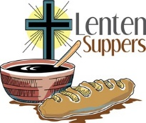

Watch the March Honeycomb for more information for the Lenten luncheons that will be hosted at some area churches.

Here are dates for the Lenten gatherings. The locations are yet to be determined. More information will be shared as it is announced.

March 4 Lunch, March 11 Dinner, March 18 Dinner, March 25 Dinner. The Lunch date will take place at Noon and the Dinners will be at 6pm.

****FEBRUARY SAMARITIAN SHOEBOX ITEM IS:

Valentine clearance items

(stuffed animals, small toys)

Leesburg ECO Presbyterian Church

1831 Perry Highway

Volant, PA 16156

And Bar Soap

\*Please place all donations in the bin marked under the table at the top of the stairs-all items will be placed on a spreadsheet for tally

throughout the year

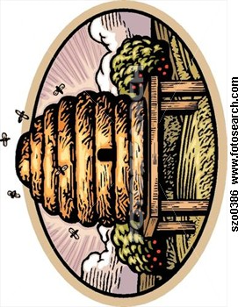



Mark & Dayna Blair – Beijing, China

**January 28 – February 3**

Mike & Carrie Meals, 81 Falls Rd., Mercer 16137

Annette Mershimer, 812 Lakeshore Blvd., Sidell, LA 70461

**February 3-10**

Marjorie Miklos, 507 W. Cornell Rd. Mercer 16137

George & Barb Mullett, 303 Boyers Rd., Harrisville, PA 16038

**February 11-17**

Phyllis Myers, 675 Flower Ave., Grove City 16127

Pete, Julie & Lily Neal, 2498 Shadowbrook, Wexford, PA 15090

**February 17-24**

Emmett & Gerry Orr, 1522 Lee Lane, Grove City, PA 16127

Joanne Orr, 354 Cannery Rd., New Wilmington 16142

**February 25-March 3**

Patty Patterson, 1389 Perry Hwy., Mercer 16137

Liz Pearson, Orchard Manor, 20 Orchard Drive, Grove City, PA 16127

**Boy Scout Troop 76 will be hosting a Soup Lunch on Sunday, February 2nd, 11am-2pm at the Knights of Columbus hall in Grove City (1310 S. Center St. Ext.) $5 includes choice of Soup (Chili, Potato, or Chicken Noodle), salad, dessert, and drink. Take outs are available. See Andy or Sam Wilson with any questions.**



[This Photo](http://www.dougberger.net/archive/2012/07/boy-scouts-anti-lgbt-policy-drips-with-religious-right-bigotry-code-words.html) by Unknown Author is licensed under [CC BY-NC-ND](https://creativecommons.org/licenses/by-nc-nd/3.0/)

**60+** will meet at White Chapel on Thursday, Feb 6th.

60+ group meets on the 1st Thursday of each month. This group alternates their gatherings between Leesburg ECO Presbyterian, White Chapel Methodist, and Rich Hill Presbyterian Churches.

Those attending arrive around 11:30 a.m. to visit, and the meal begins at 12:00 Noon, followed by a brief program of some sort arranged by the host church. Those who attend are asked to bring a pot luck item of their choice to share with the others who are present. It could be a casserole, or a salad, or a dessert.

Leesburg will host 60+ on Thursday, March 6th.



**Josh & Alexis Jaszemski**

February 7, 2018

**Paul & Kathy McConnell**

February 18,1984

**Jack & Sue Grimm**

February 20,1993

1 Tom Bobbert 20 Sue Grimm

2 Marian Dambach Sheila Enscoe

3 Dotty Lewis 23 Larry Geiwitz

Lisa Schepp 24 Dave Boyer

4 Doug Latimer 26 Kim Hurst

7 Tom Booth Jodi Hensel

10 Donna Hensel Harold Ifft

11 Gordon Hensel Bob Thompson

14 Austin Saccol Jason Baughman

15 Pat Thompson Brenda Smoker

Frank Baker 27 Caleb Shawgo

16 Georgia Rogers 28 Patty Brest

REMEMBER OUR SHUT-INS WITH A VALENTINE CARD

**Brenda Barkley Patty Brest**

SR Amity Personal Care Home 520 S. New Castle St.

276 Ralston Rd. The Grove #67

Slippery Rock, PA 16057 New Wilmington, PA 16142

**Marian Dambach Liz Pearson**

297 Chapel Drive Orchard Manor,

Ellwood City, PA 16117 20 Orchard Drive

Grove City, PA 16127

**Marjorie Miklos Judy Steele**

507 W. Cornell Rd. P O Box 102

Mercer, PA 16137 Volant, PA 16156

**Bill & Mary Turner Gerry Wages**

1585 Perry Hwy. 301 S. Broad St. #610

Mercer, PA 16137 Grove City, PA 16127

**Tom & Tamie Bobbert Bob & Pat Thompson**

105 Patrick Henry Dr. 197 Orr Rd.

Louisa, VA 23093 Mercer, PA 16137

**Leroy & Donna Grimm Bill & Mary Turner**

73 Leesburg Station Rd. 1585 Perry Hwy.

Volant, PA 16156 Volant, PA 16156

Have you ever wondered what the Deacons do or why we designate the loose offering on Communion Sundays to the Deacon Fund……CONTINUE READING …..

A Deacon ministers to those who are in need, to the sick and to anyone who may be in distress. The loose offering from “Communion” Sundays as well as a pre-determined portion of the benevolence given each quarter and other donations from the congregation or community help provide assistance to families in need of money for fuel oil, transportation costs to the hospital, food/gift cards for groceries, assistance in paying utilities, help due to total loss of a home in a fire as well as serving funeral dinners to families who lost a loved one. Deacons also purchase gifts for our homebound when we carol at Christmas. Without the generous donations that they receive, none of the above would be possible. This is done confidentially. If you know of someone needing assistance, please contact a Deacon or Pastor Jeff.

****

Greg Kingsley

http://download.churchart.com/ArtLineLibrary/u/us/usher6c.gif

Ed & Sue Schepp

blood pressure_1854_50

**19th & 23rd** Charlotte Yeager

 7th Charlotte Yeager & Margaret Ifft

14th Pat & Prugh Barger

21st Jim& Kathy Schepp

28th Gordon Hensel & Bob Frisk



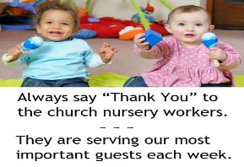

**Date Liturgist Greeter s Nursery**

2nd Jodi Smith Warren & Bruce

9th Jon Stewart Billie Jo & Judy Julie Mayberry

16th Rick & Karen Missy Davies

23rd Jack & Julie Bethany & Selah Smith



CONGRATULATIONS to **Abby Weller** who was selected for PMEA District Chorus and will now be moving on to Region Chorus!!



The Mission Shaped Church Committee is continuing their toiletry collection to benefit local shelters now and into 2020.  If you travel and do not use the hotel/motel toiletries and wish to donate them, please bring to the church and place into one of the collection bins under the table at the top of the stairs.



VBS dates and curriculum are being discussed and will be shared as soon as a schedule is set and ready. If you are interested in helping with VBS this year, please contact the church office soon.

We hope that you will remember to INVITE YOUR FRIENDS TO JOIN YOU

**Thank you to everyone who stayed and bought lunch from Jr. CE at their Soup Luncheon Fundraiser on January 12th and for those who helped in anyway including prayers. The luncheon was a success and the funds collected will go towards their missions and camps!!!**

Special Thanks to the Trustees and members of the Connection Team for the painting of the foyer, overflow, welcome area, and upstairs hallway and replacement of the older light fixtures. And the connection team for beginning the work on the upstairs restrooms.

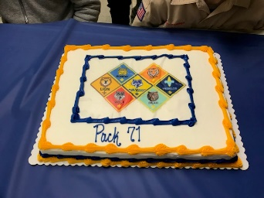**BLUE AND GOLD BANQUET** was held at 6 p.m. January 23rd here at the church. This was a fun night to support our cub scout that meet here at our church. The boys have been busy throughout the year and the belt loops, pins, and badges they have earned were given to the scouts who earned them. This is also the time that any cub scout who meets the requirements to “cross-over” to become a boy scout were honored by crossing over the bridge.

**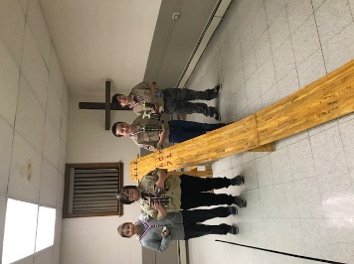PINEWOOD DERBY:**

The pinewood derby was held on January 23rd. Results are Wiley Schepp was 1st, Austin Yeager was 2nd, Brady Wilson was 3rd, and John Foust was 4th. Brady was awarded Best in Show!!

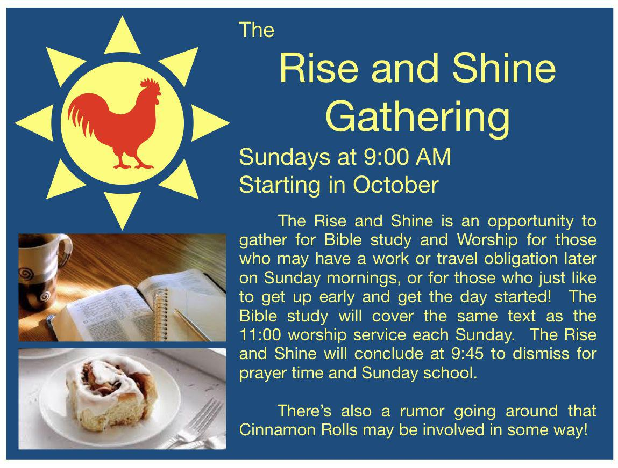

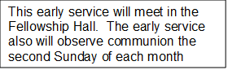

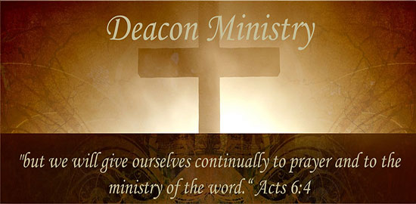

Throughout the year the Board of Deacon’s offers help to families when they experience the loss of a loved one by providing a meal as the family gathers. If you would be willing to help with this mission, usually by providing a cake, please list your contact information below. **Whether or not you have helped in the past, please let us know your wishes for 2020.** Pat Barger or Doris Steffan will be in touch with you if a need arises. This form may be placed in the offering plate or given to Kathy Schepp.

\_\_\_I wish to be added to the list.

Name:\_\_\_\_\_\_\_\_\_\_\_\_\_\_\_\_\_\_\_\_\_\_\_\_\_\_\_\_\_\_\_\_\_\_\_\_\_\_\_

Phone:\_\_\_\_\_\_\_\_\_\_\_\_\_\_\_\_\_\_\_\_\_

\_\_\_I wish to remain on the list.

Name:\_\_\_\_\_\_\_\_\_\_\_\_\_\_\_\_\_\_\_\_\_\_\_\_\_\_\_\_\_\_\_\_\_\_\_\_\_\_\_

Phone:\_\_\_\_\_\_\_\_\_\_\_\_\_\_\_\_\_\_\_\_\_

\_\_\_I wish to be removed from the list.

Name:\_\_\_\_\_\_\_\_\_\_\_\_\_\_\_\_\_\_\_\_\_\_\_\_\_\_\_\_\_\_\_\_\_\_\_\_\_

Phone:\_\_\_\_\_\_\_\_\_\_\_\_\_\_\_\_\_\_\_\_



Leesburg ECO Presbyterian Prayer Chain

The Deacons are re-organizing the Prayer Chain for 2020.

Kathy Schepp will continue as the Prayer Chain Coordinator, for this year. Prayer requests may be made by contacting Kathy via one of the following ways:

~Email – [mschepp@zoominternet.net](mailto:mschepp@zoominternet.net)

~Texting or calling - 724-301-4890 (please feel free to leave a voice message)

~Home phone - 724-748-4800 (please feel free to leave a voice message)

~Or by contacting Tracy Jaszemski through the church office (724-748-4670).

If you are currently on the prayer chain, Kathy will be in touch with you to see if you wish to continue serving the Lord by praying for needs as they arise.

If you would like to join our prayer team, please fill out the form below and place it in the offering plate:

Name \_\_\_\_\_\_\_\_\_\_\_\_\_\_\_\_\_\_\_\_\_\_\_\_\_\_\_\_\_\_\_\_\_\_\_\_\_\_\_\_\_\_\_\_

Contact me by (list information for one):

Email: \_\_\_\_\_\_\_\_\_\_\_\_\_\_\_\_\_\_\_\_\_\_\_\_\_\_\_\_\_\_\_\_\_\_\_\_

Text message: \_\_\_\_\_\_\_\_\_\_\_\_\_\_\_\_\_\_\_\_\_\_\_\_\_\_\_\_\_

Phone call: \_\_\_\_\_\_\_\_\_\_\_\_\_\_\_\_\_\_\_\_\_\_\_\_\_\_\_\_\_\_\_\_