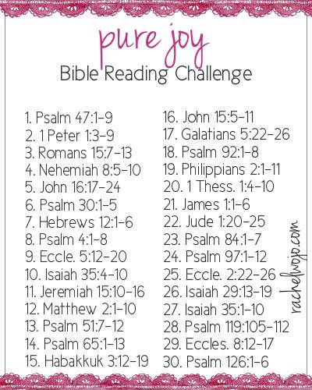

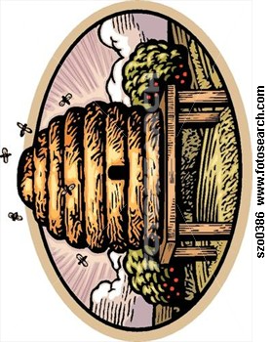

Leesburg ECO Presbyterian Church

1831 Perry Highway

Volant, PA 16156

****

**Grove City Food Pantry**

**THANK YOU** to all the people at Leesburg church for their food donations to the GC Food Pantry. You continued donations are so appreciated!

http://download.churchart.com/ArtLineLibrary/u/us/usher6c.gif

**July Prayer Families**

**July 1-7**

Travis, Beth, Hannah, Abby, Mimi & Liam Weller

203 State St., Grove City 16127

**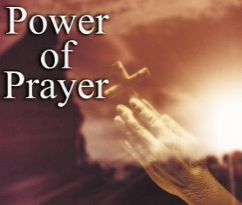**Dick & Judy Welton

175 Oregon Rd., Mercer 16137

**July 8-14**

Deborah Wilkins

682 Flower Ave., Grove City 16127

Brad, Katie, Andy, Sam & Brady Wilson

122 Pennsy Rd., Volant 16156

**July 15-21**

Dave & Pat Woods

742 New Castle Mercer Rd., Mercer 16137

Greg, Katie, Hannah & Abby Woods

1695 Perry Hwy., Volant 16156

**July 22-28**

Sandy Yarian

884 Leesburg Station Rd., Volant 16156

Charlotte Yeager

1898 Perry Hwy., Volant 16156

**July 29-Aug 4**

Peter & Judie Yurchison

8210 Superior NE, Masury OH 44438

Terri Barcheck

1346 Potter Run Rd., Volant 16156



Pickle Harris

The Latimer Family

blood pressure_1854_50

July 14th & 28th Liz Kingsley

 5th Charlotte Yeager & Margaret Ifft

12th Pat & Prugh Barger

19th George & Betsy Horchler

26th Gordon Hensel & Bob Frisk

THANK YOU FOR YOUR WILLINGNESS TO HELP! Here is a list of volunteers for July…..



**Date Liturgist Greeter Prayer Leader**

July 7th Gabby Collins Kathy/Bruce Travis Weller

May 14th Amelia Weller Bruce/Warren Kathy Schepp

May 21st Andy Wilson Warren/Cindy Maryann Collins

May 28th Madelyn Rogers Cindy/Doug \*\*

Hospital Visitation for July—

Session Member—Cindy Barcheck & Deacon—Stacey Booth

MC900151701[1]

4 Jim Schepp 21 Chelsea McConnell

Will Harris Carrie Meals

7 Pete Ellis 24 Barb Cummings

9 Josh Schepp Bruce Curfman

13 Joanne Orr 26 Emmett Orr

18 Phyllis Smith 29 Charlotte Yeager

19 Deb Sonntag Kathy Dillaman

Gracie Harris Warren Enscoe

30 Jack Grimm, Jr

31 Larry Mathieson



1st Dave & Pat Woods 1972

3rd Bruce & Ruth Curfman 1993

9th Tom & Kathy Bell 1978

11th Mark & Michele Bonnici 1992

Bob & Pat Thompson 1952

15th Marc & Brenda Smoker 1989

24th Rick & Tammi Martin 1993

28th Greg & Liz Kingsley 1990

**NURSERY CARE** is needed for the remainder of the year. If you could help in the nursery, please see Liz Kingsley or Tracy Jaszemski to sign up. The nursery will not have an attendant for the summer months, but we hope to fill the schedule beginning in September.

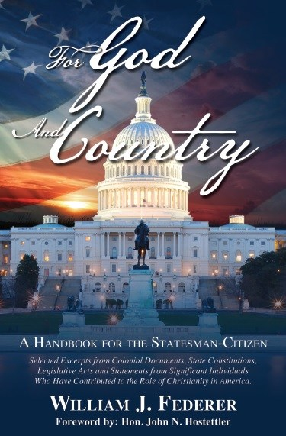God and Country- VBS was hosted June 17-20 and fun was had by all who attended and helped!! We had an average of 37 kids each evening!! We thank everyone for all your help and prayers through this week. To Gail Voltz for her ideas and concept and to Pastor Jeff for heading the week!! The children learned through bible study classrooms, an opening and closing gathering each night which included a time machine and visits from some old characters. The weeks focus was on Helpfulness, Thankfulness & Hopefulness. Thank you, Leesburg, for always stepping up and being a team player!

Welcome to the Community Bags: If you have a new family in your neighborhood, why not introduce yourself with a welcome bag from our church. See Pat Woods or Tracy Jaszemski to get 1 or more. Inside are maps of the county, township, Grove City, Mercer, lists of restaurants, hospitals, churches, doctors.  Pamphlets from various businesses in the area.  Coupons for some places.  Brochures from the nursing homes, hotels, etc.  All kinds of information including activities within the county.  Also included is a letter from us and our pamphlet we place at the local hotels.

**SPECIAL THANKS** to each one who brought items for our Veteran’s Warrior box. Springfield Twp., Stanley Snyder Post collected 2+ pickup truck loads of items. Bless each of you for your donations

**UPCOMING DATES FOR AUGUST:**

1st 12pm 60+ at White Chapel

4th 6-7 pm Senior CE

7-8 pm Prayer Group

10th all day 15-mile yard sale along Route 208

11th 12 pm BP screening

17th all day Fellowship Hall Reserved

22nd 6 pm Ladies dinner at Eat N Park

25th 11 am Communion Service

12 pm BP screening

28th 6:30 pm Session Meeting

Donations are always accepted for the Samaritan’s Purse shoeboxes. We would love to pack 500 boxes for the Christmas season. For July-please bring in bar soap or kids toys. For August-please bring in notebooks, crayons, glue sticks and child size t-shirts.

Thank you for all your help in reaching our goal of 500!!!

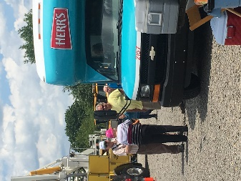

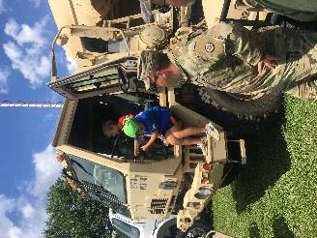SPECIAL THANKS TO ALL WHO HELPED MAKE OUR ANNUAL **TOUCH A TRUCK** EVENT ANOTHER WONDERFUL SUCCESS!!! THERE WERE 40+ EXHIBITORS WITH APPROXIMATELY 800+ VISITORS WHO ATTENDED THE EVENT. PHYLLIS AND THE TAT COMMITTEE DID AN AWESOME JOB OF ORGANIZING THE EVENT AND HELPING TO OPEN OUR “DOORS” TO MANY IN OUR AREA.

Special Prayers and Blessings for our recently baptisms:



**Murray Miller- May 5th**

**Lizzie House-May 19th**

**Mia Schepp-May 26th**

**Hannah & Abby Woods-June 9th**

**MEMORIAL PARK FOUNTAIN WORKING ONCE AGAIN**

A time-honored treasure of Grove City Memorial Park is functioning once again thanks to the diligence and talent of 2019 Grove City High School graduate, Zane “Pete” Grimm. Pete, a son of Jack and Sue Grimm, Volant, PA, spearheaded the re-construction of the plumbing system of the fountain, and he brought on board the talents of his Dad Jack Grimm Jr., Chuck Dininger, Rick Martin, Scoutmaster Jerod Hamilton, and the Scouts of Mercer Troop 83. Always cheering in the background was his “Pa”, Jack Grimm, Sr. This endeavor to restore a fountain that had not been operational for many, many years was enthusiastically supported by the Borough of Grove city and many local folks who stopped by any day the crew was on site working to reminisce about ‘fountain memories of days gone by’. This treasure of Grove City’s history took 46 buckets of hydraulic cement, 10 gallons of waterproof paint, and a lot of wire mesh, along with other materials to restore to working condition so that we all can enjoy it for many years to come. Once the materials were acquired the labor took about a month to complete. Next on Pete’s agenda is to obtain a nursing degree, and he has been accepted into the program at Penn State, Shenango campus.



**GriefShare** begins August 12th and will conclude on November 4th. We will host 2 dates of “Surviving the Holidays”, on November 18th and December 16th. GriefShare is a Christ-centered, video-based ministry that helps people grieving a loved one’s death.  Invite your family & friends to come together to discuss 13 different topics concerning grief.  We will meet each week in the fellowship hall from 6:00 – 8:00.  Please sign up in the office to let us know you will be attending.

16. Peace-loving. “Father, let my children ( ) make every effort to do what leads to peace” (Rom. 14:19)

1. Joy, “May my children ( ) be filled with the joy given by the Holy Spirit” (1 Thess. 1:6)
2. Perseverance. “Lord, teach my children ( ) perseverance in all they do, and help them especially to run with perseverance the race marked out for them” (Heb. 12:11)
3. Humility. “God, please cultivate in my children ( ) the ability to show true humility toward all” (Titus 3:2)
4. Compassion. “Lord, please clothe my children ( ) with the virtue of compassion” (Col. 3:12)
5. Responsibility. “Grant that my children ( ) may learn responsibility, for each one should carry his own load” (Gal. 6:5)
6. Contentment. “Father, teach my children ( ) the secret of being content in any and every situation, through Him who gives them strength” (Phil. 4:12-13)
7. Faith. “I pray that faith will find root and grow in my children’s ( ) hearts, that by faith they may gain what has been promised to them” (Lk. 17:5-6, Heb. 11:1-40)
8. A servant’s heart. “God, please help my children ( ) develop servants’ hearts, that they may serve wholeheartedly, as if they were serving the Lord, not men” (Eph. 6:7)
9. Hope. “May the God of hope grant that my children ( ) may overflow with hope and hopefulness by the power of the Holy Spirit” (Ro. 15:13)
10. Willingness and ability to work. “Teach my children ( ), Lord, to value work and to work at it with all their heart, as working for the Lord, not for men” (Col. 3:23)
11. Passion for God. “Lord, please instill in my children ( ) a soul that ‘followeth hard after thee’ (Ps. 63:8, KJV), one that clings passionately to you.
12. Self-discipline. “Father, I pray that my children ( ) may acquire a disciplined and prudent life, doing what is right and just and fair” (Prov. 1:3)
13. Prayerfulness. “Grant, Lord, that my children’s ( ) lives may be marked by prayerfulness, that they may learn to pray in the Spirit on all occasions with all kinds of prayers and requests” (Eph. 6:18)
14. Gratitude. “Help my children ( ) to live lives that are always overflowing with thankfulness and always giving thanks to God the Father for everything, in the name of our Lord Jesus Christ” (Eph. 5:20, Col. 2:7)
15. A heart for missions. “Lord, please help my children ( ) to develop a desire to see your glory declared among the nations, your marvelous deeds among all peoples” (Ps. 96:3)

31 Biblical Virtues to Pray for your Kids

(or grandkids, nieces, nephews, etc.)

By Bob Hostetler

(Excerpted from *Pray!*, issue #4)

1. Salvation. “Lord, let salvation spring up within my children ( ), that they may obtain the salvation that is in Christ Jesus, with eternal glory” (2 Pet. 3:18)
2. Growth in grace. “Grant, Lord, that my children ( ) may grow in the grace and knowledge of our Lord and Savior Jesus Christ” (2 Pet. 3:18)
3. Love. “Grant, Lord, that my children ( ) may learn to live a life of love, through the Spirit who dwells in them: (Gal. 5:35, Eph. 5:2)
4. Honesty and integrity. “May integrity and honesty be their virtue and their protection: (Ps. 25:21)
5. Self-control. “Father, help my children ( ) not to be like many others around them, but let them be alert and self-controlled in all they do” (1 Thess. 5:6)
6. Love for God’s Word. “May my children ( ) grow to find Your Word more precious than much pure gold and sweeter than honey from the comb: (Ps. 19:10)
7. Justice. “God, help my children ( ) to love justice as You do and act justly in all they do” (Ps. 11:7, Mic. 6:8)
8. Mercy. “May my children ( ) always be merciful, just as their Father is merciful” (Lk. 6:36)
9. Respect (for self, others, authority). “Father, grant that my children ( ) may show proper respect to everyone, as your Word commands” (1 Pet. 2:17)
10. Biblical self-esteem. “Help my children ( ) develop a strong self-esteem that is rooted in the realization that they are God’s workmanship, created in Christ Jesus” (Eph. 2:10)
11. Faithfulness. “Let love and faithfulness never leave my children ( ), but bind these twin virtues around their necks and write them on the tablet of their hearts” (Prov. 3:3)
12. Courage. “May my children ( ) always be strong and courageous in their character and in their actions” (Dt. 31:6)
13. Purity. “Create in them a pure heart, O God, and let that purity of heart be shown in their actions” (Ps. 5:10)
14. Kindness. “Lord, may my children ( ) always try to be kind to each other and to everyone else” (1 Thess. 5:15)
15. Generosity. “Grant that my children ( ) may be generous and willing to share, and so lay up treasure for themselves as a firm foundation for the coming age” (1 Tim. 6:18-19)